Technical Report
for
DOCPLAN

Prepared by
Group Name: GROUP 31
24/U/0273 |  | 2400700273 |  | ATUGONZA MATHIAS
24/U/04844/PS |  | 2400704844 |  | IGA AALIYAH
24/U/24148/PS |  | 2400724148 |  | LUBANGA SHAFICK
24/U/24775/PS  24/U/02848/EVE |  | 2400724775  2400702848 |  | SSERUWAGI MARVIN  AHURIRA GRACE
 | Mentor: |  | PADDY ASIIMWE
 | Course: |  | CSC 1304 Practical Skills Development
 | Date: |  | 28th July, 2025

Contents
Contents ii
Abstract iii
1 Introduction 1
1.1 User Challenge 1
1.2 Project Goals 1
1.3 Functional Requirements 2
2 Project Results 3
2.1 Product Design 3
2.2 Product Functionality and Screenshots 3
3 Limitations and Next Steps 6
3.1 Limitations 6
3.2 Next Steps 6
References Error! Bookmark not defined.
4 Appendix A – Project Work plan 7
Appendix B – Contribution by Team Members 8

Abstract

This project addresses the challenges faced by healthcare providers and patients in managing medical appointments effectively. In many healthcare settings, doctors often encounter difficulties in organizing their schedules, leading to missed appointments, double bookings, and delayed patient care. Patients, on the other hand, struggle to find suitable time slots and are often left uninformed about schedule changes. These issues result in wasted time, poor service delivery, and inefficiencies in hospital operations.

To solve this, we developed a Doctor-Patient Appointment Scheduling System – a web and mobile application designed to simplify and automate appointment management. The system allows patients to book, view, and manage appointments with their doctors, receive real-time notifications, and access appointment history. Doctors can set their availability, view upcoming appointments, accept or decline requests, and get notified of emergencies. Additional features like and an emergency alert button further enhance the system’s responsiveness.

This solution improves healthcare service delivery by minimizing scheduling conflicts, optimizing doctors’ time, and enhancing the overall patient experience.

Introduction.
The purpose of this document is to provide a detailed overview of the Doctor-Patient Appointment Scheduling System, highlighting its objectives, scope, and functionality. It outlines the challenges in current appointment management processes within healthcare settings and presents the proposed digital solution designed to address these issues.
This document serves as a guide for understanding the system’s design, features, and intended impact on improving efficiency for doctors and convenience for patients. It is intended for stakeholders, developers, and end-users to gain insight into the project’s goals and how the solution simplifies healthcare appointment management.

User Challenge
In many healthcare settings, doctors and patients face significant challenges in managing medical appointments effectively. Doctors often forget scheduled appointments or fail to attend due to overlapping bookings or lack of timely reminders. This results in wasted time, underutilized hospital resources, and delays in service delivery. On the other hand, patients struggle to find available time slots that align with their schedules, and they are often unaware of sudden changes in a doctor’s availability, leading to frustration and poor healthcare experiences.
Addressing this problem is critical because effective appointment management is essential for ensuring smooth hospital operations and delivering quality patient care. Without a reliable system, healthcare providers risk operational inefficiencies, while patients experience longer wait times and decreased satisfaction. A digital solution that streamlines scheduling and provides real-time updates can greatly improve healthcare service delivery for both parties.

Project Goals
The Docplan is a software solution designed to streamline and optimize the process of managing medical appointments between healthcare providers and patients. The purpose of the project is to eliminate common challenges such as missed appointments, scheduling conflicts, lack of reminders, and inefficiencies in communication. By leveraging a digital platform, the system aims to improve service delivery, reduce waiting times, and enhance the overall patient experience.
The system allows patients to easily book, view, and manage appointments, as well as check their appointment history. On the other hand, doctors can manage their schedules by setting available slots, approving or rejecting appointments, and accessing upcoming appointments. The solution integrates innovative features such as real-time notifications, and an emergency alert button that overrides regular scheduling in urgent cases. The key objectives of this project include improving time management, enhancing communication between doctors and patients, reducing missed appointments, and ensuring prompt responses to emergencies
The Doctor-Patient Appointment Scheduling System is a digital platform designed to simplify and optimize the process of managing medical appointments. It enables patients to book, view, and manage appointments with doctors easily while providing doctors with tools to set their availability, accept or decline appointments, and receive real-time notifications.
This product directly addresses the challenges identified in appointment management by automating scheduling, sending timely reminders, and preventing double bookings or missed appointments. Its real-time notifications and emergency prioritization features ensure both doctors and patients remain informed and responsive. By integrating these advanced functionalities, the system goes beyond traditional appointment tools, offering a more efficient, user-friendly, and responsive solution to improve healthcare service delivery.

Functional Requirements
Patient Functional Requirements
These requirements define the operations and services available to patients:
- Account Management
  - Patients can register and create a personal profile with basic details (name, contact, medical history – optional).
  - Patients can log in securely using their credentials.
  - Patients can update or delete their profiles.
- Appointment Booking and Management
  - Patients can view a list of available doctors with their specializations and availability slots.
  - Patients can view, edit, or cancel their booked appointments.
  - Patients can view appointment history for their records.
- Notifications and Alerts
  - Receive confirmation notifications for new bookings, cancellations, and changes.
  - Get reminders for upcoming appointments via SMS, email, or in-app notifications.
  - Emergency alert button to notify doctors in critical situations and request priority attention.

Doctor Functional Requirements
These requirements define the system functions available to doctors:
- Account Management
  - Doctors can register and create a professional profile with details such as name, specialization, and availability.
  - Doctors can log in securely using credentials.
  - Doctors can update their profiles as needed.
- Appointment Management
  - View a dashboard of upcoming appointments with details of each patient.
  - Accept or decline appointment requests from patients.
  - Set and update available time slots to manage their schedules.
  - Receive real-time notifications about new bookings, cancellations, or emergency alerts.
- Emergency Override Feature
  - Respond to patient emergency alerts by prioritizing or rescheduling existing appointments.
  - View a list of emergencies in order of priority.

- System-Wide Functional Requirements
- Security and Privacy
  - Ensure secure login and session management for all users.
  - Encrypt sensitive data such as patient records and appointment details.
- Real-Time Notifications
  - Provide instant updates to users about their appointments and system events.
- Multi-Platform Support
  - Support both web and mobile platforms for accessibility.

Project Results

Product Design
System Architecture Overview
• Presentation Layer (Front-End):
This is the user interface accessible via web browsers and mobile devices. It allows patients and doctors to interact with the system through intuitive dashboards and forms. Technologies: ReactJS (Web), Flutter (Mobile).
• Data Layer (Database):
Stores all persistent data including user profiles, appointment details, notification logs.
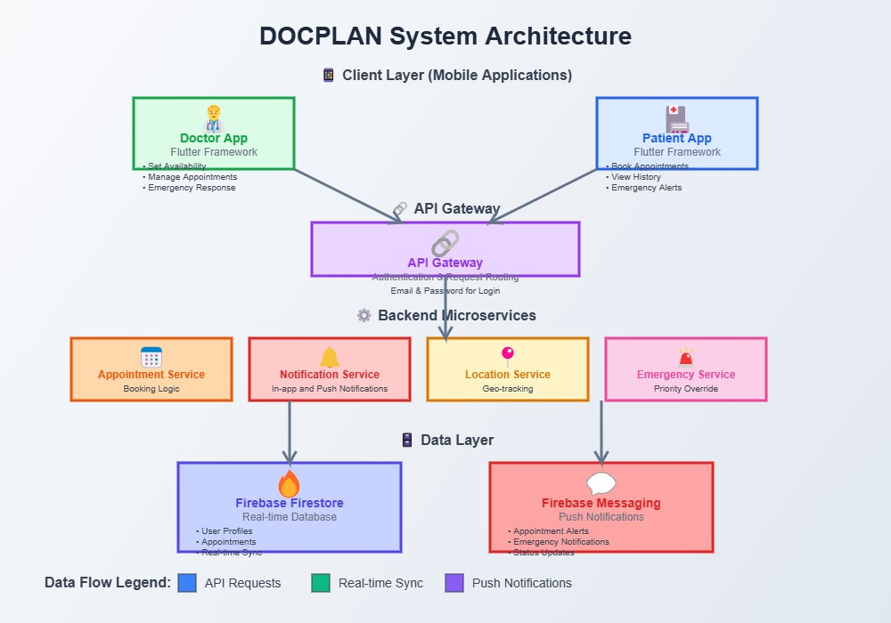
System Design Diagram
System Components Description
- Front-End Components:
  - Patient Portal: Interface for booking, managing, and tracking appointments.
  - Doctor Portal: Dashboard for setting availability, managing appointments, and handling emergencies.
- Back-End Components:
  - Appointment Module: Handles scheduling logic, conflict resolution, and appointment history.
  - Notification Module: Sends real-time updates through email, SMS, or in-app notifications.
  - Emergency Handler: Overrides normal scheduling for critical alerts from patients.
- Database Components:
  - Tables for Users, Doctors, Appointments, Notifications, and Emergencies.
  - Security Features: HTTPS communication, token-based authentication (JWT), and role-based access control.

Product Functionality and Screenshots
Patient Module
The Patient Module enables patients to interact with the system by booking and managing appointments, receiving notifications, and accessing additional services.
- a) User Registration and Login
  - Patients can register by providing their details and login securely.
  - Features validation and encryption of login credentials.
- b) Appointment Booking
  - Patients can search for doctors by specialization or availability.
  - Book an appointment by selecting date, time, and doctor.
- c) Appointment Management
  - View, edit, or cancel upcoming appointments.
  - Access past appointment history for reference.
- d) Notifications and Emergency Alerts
  - Receive reminders and updates on appointment status.
  - Use the emergency alert button to notify doctors during critical situations.

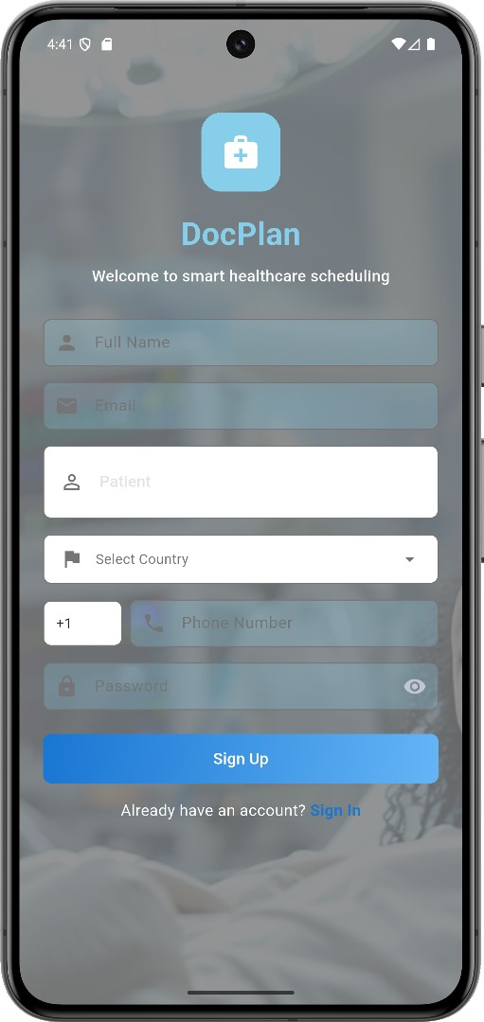
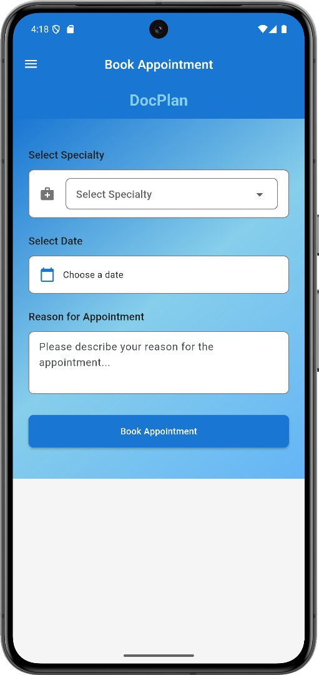
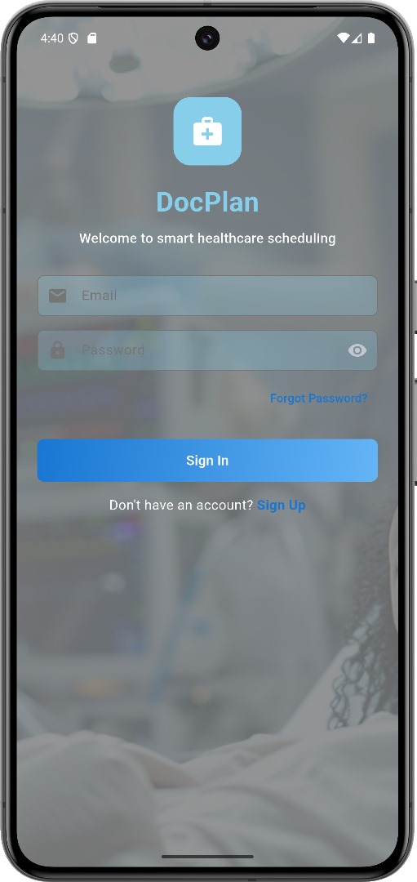
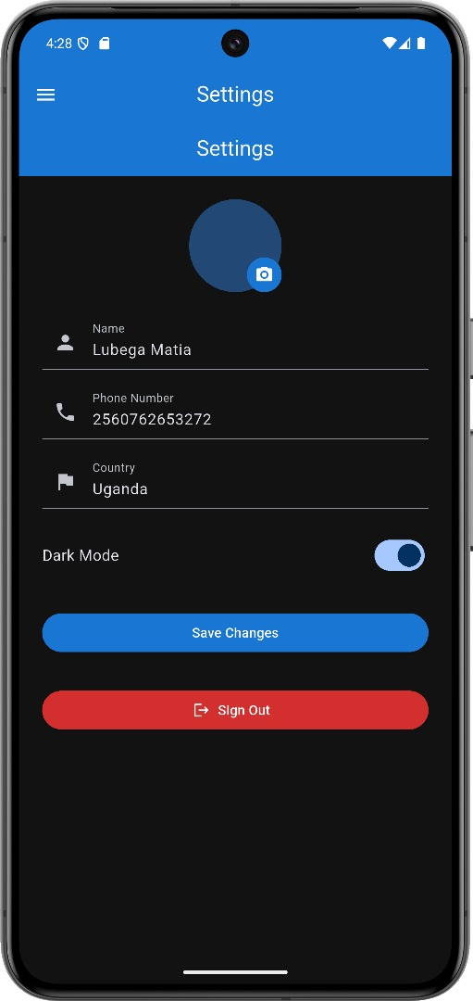
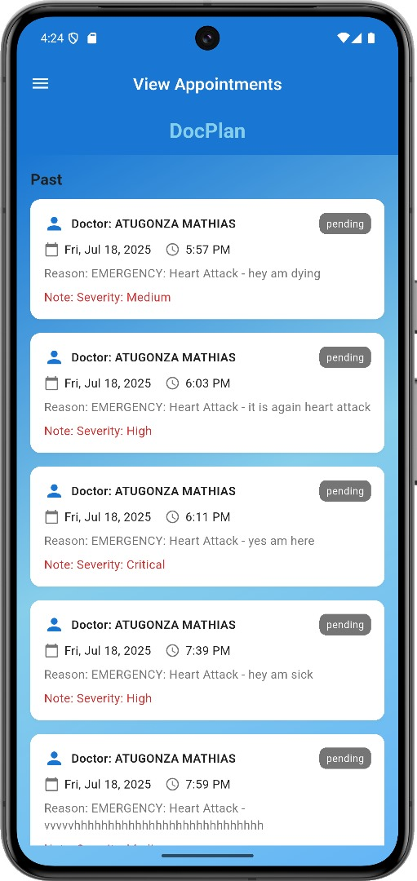
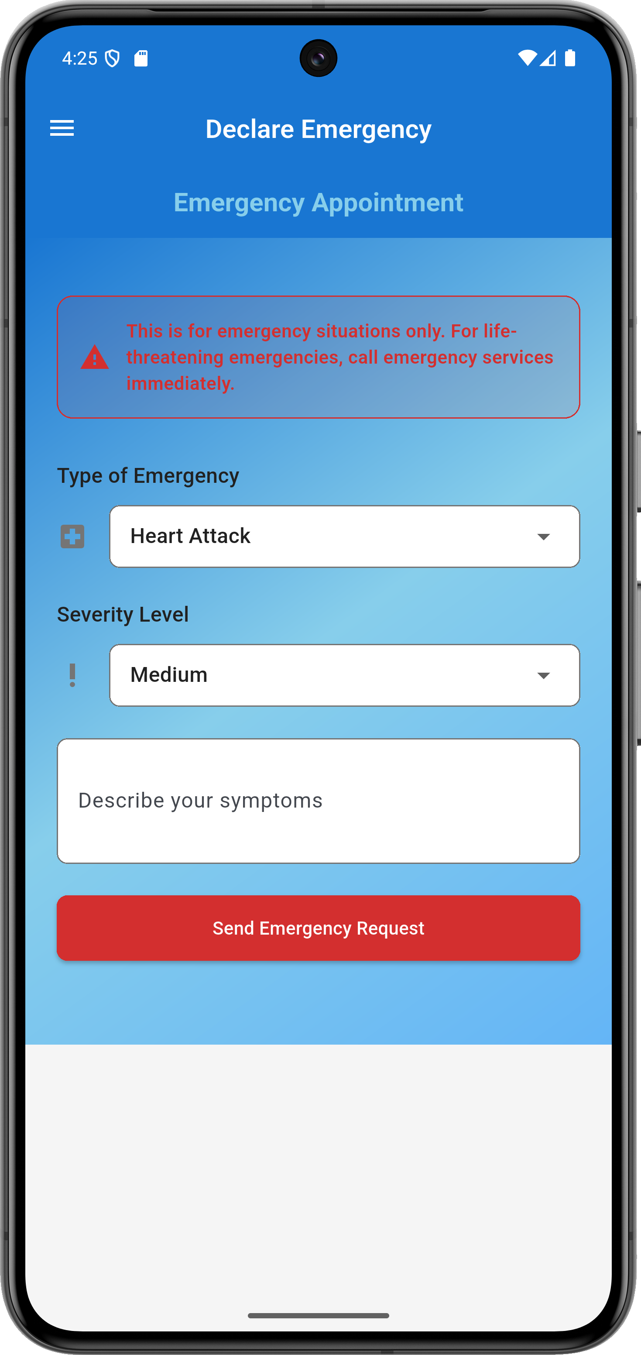
Doctor Module
The Doctor Module provides tools for doctors to manage their schedules, view patient information, and handle emergencies effectively.
- a) Doctor Profile Management
  - Create and edit professional profiles including specialization, contact details, and availability.
- b) Appointment Dashboard
  - View all upcoming, pending, and past appointments.
  - Accept or decline appointment requests with reasons if necessary.
- c) Emergency Override Feature
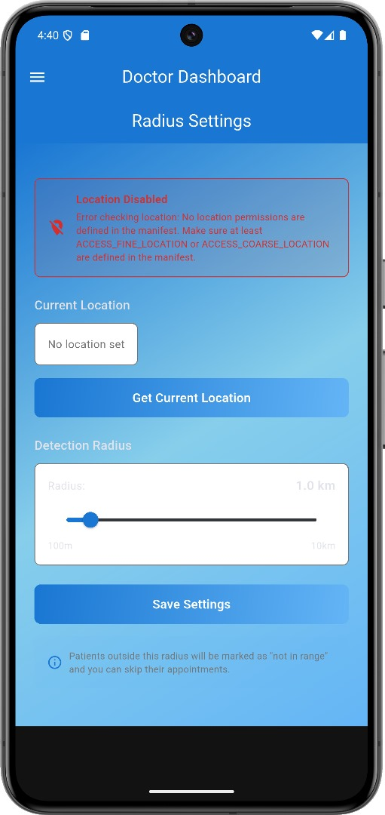
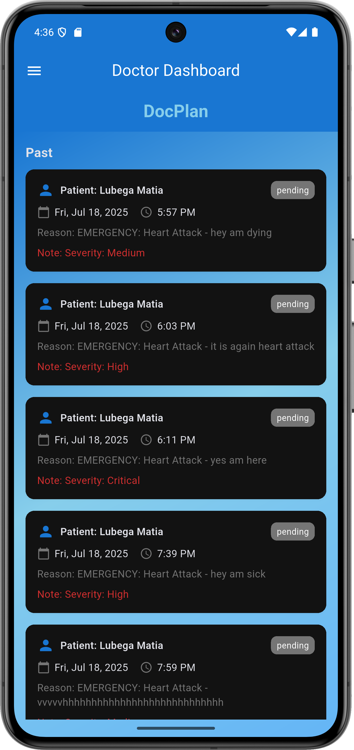
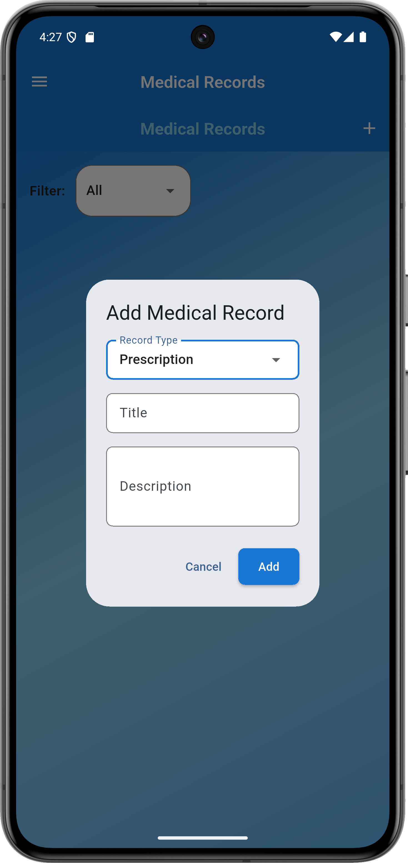
  - Receive emergency alerts from patients and prioritize them over normal appointments.
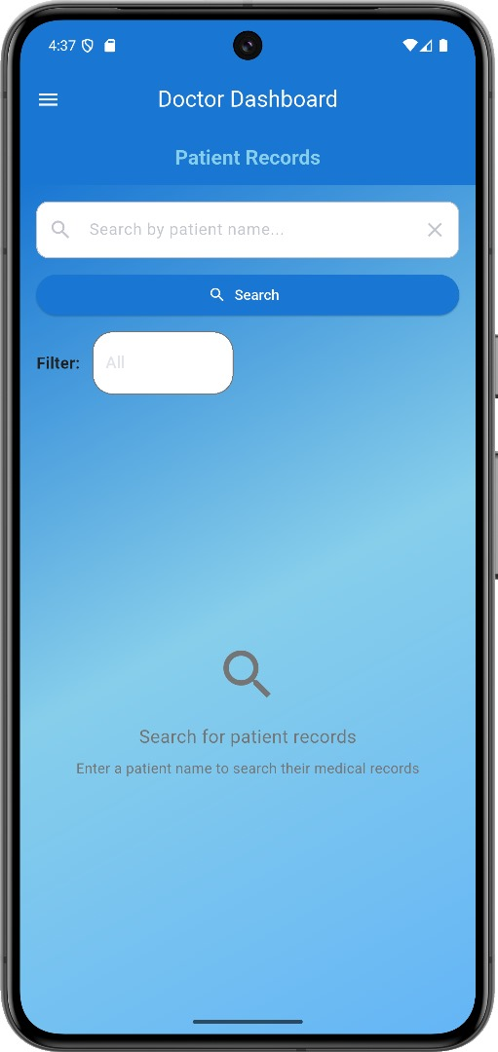
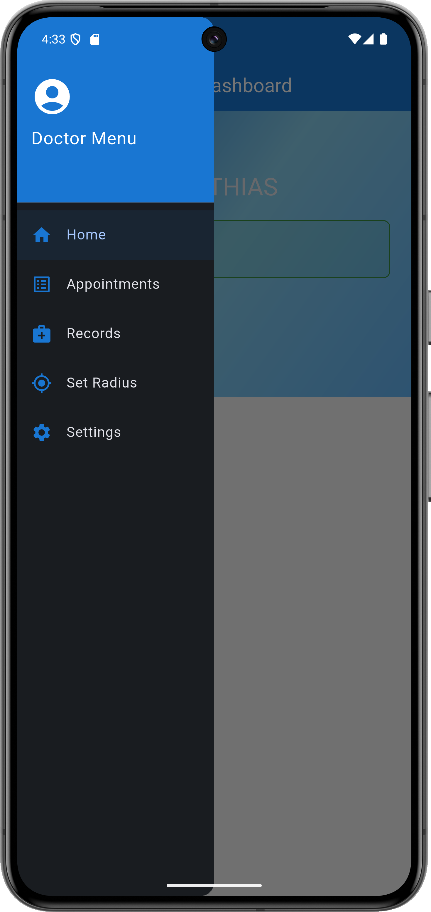
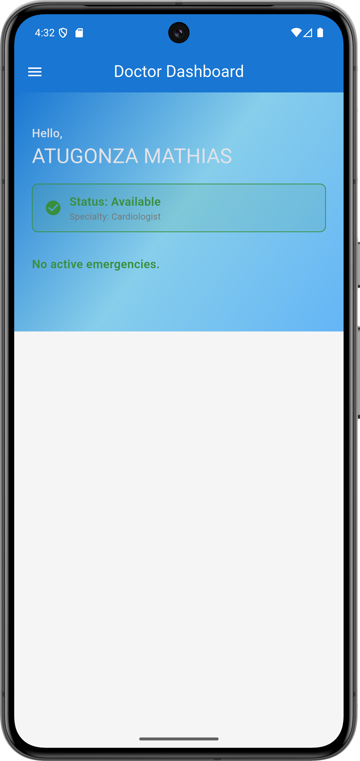

Project website and repository
Below are the publicly available links to the project’s website and source code repository:
- 🌐 PROJECT WEBSITE: https://aaliyah-101.github.io/project-website
- 💻 SOURCE CODE REPOSITORY: https://github.com/Aaliyah-101/DocPlan.git
- 🌐 POSTER LINK: https://raw.githubusercontent.com/Aaliyah-101/DocPlan/main/assets/images/DOCPLAN_POSTER.png

Limitations and Next Steps

Limitations
While the Doctor-Patient Appointment Scheduling System successfully addresses key challenges in healthcare appointment management, there are some limitations in its current version:
- 📶 Limited Offline Functionality: The system relies on an active internet connection, making it inaccessible in areas with poor network coverage.
  - Proposed Solution: Implement offline data caching to allow users to view previously loaded information and queue appointment requests for later submission when connectivity is restored.

- 🔔 Notification Dependency: Notifications are dependent on SMS or email service providers, which may occasionally delay message delivery.
  - Proposed Solution: Integrate in-app push notifications and real-time WebSocket alerts to reduce dependency on third-party services.
- 🛡️ Limited Security Measures in Prototype: The current prototype has basic authentication but lacks advanced security features like two-factor authentication (2FA) or encryption for sensitive health data.
  - Proposed Solution: Implement end-to-end encryption and 2FA in future iterations for enhanced security.

Next Steps
Beyond the recess term, we plan to enhance the system and explore opportunities for real-world deployment:
- 🚀 Full Deployment: Deploy the application on a cloud platform (e.g., AWS, Azure, or Firebase) for public access and scalability.
- 📱 Mobile App Development: Build native Android and iOS applications for wider accessibility and improved user experience.
- 🔥 Advanced Features: Integrate machine learning for appointment trend analysis and smart scheduling suggestions for doctors and patients.
- 💳 Payment Integration: Add support for mobile money and card payments to allow patients to pay consultation fees during booking.
- 🏥 Partnerships with Local Hospitals: Collaborate with healthcare facilities to pilot the system and gather feedback for improvements.
- 🌐 Multi-Language Support: Extend support to local languages to increase adoption in diverse regions
- Geo-Fencing Accuracy: The geo-fencing feature may not work accurately in some regions or with low-end devices.
  - Proposed Solution: Combine GPS with Wi-Fi and Bluetooth-based location tracking for improved accuracy.

References
- [1] Brown, M. et al. (2023). Mobile Health Applications: User Experience. J Med Internet Res, 25(4), e12345.
- [2] Firebase Team. (2023). Firebase Documentation. https://firebase.google.com/docs
- [3] Flutter Team. (2023). Flutter Framework Docs. https://flutter.dev/docs
- [4] HIMSS. (2023). Mobile Health Survey Results. HIMSS Analytics.
- [5] Johnson, A. & Smith, J. (2023). Healthcare Appointment Scheduling. HealthTech J, 15(3), 45-62.
- [6] WHO. (2022). Digital Health Technologies. WHO Technical Report Series, No. 998.

Appendix A – Project Work plan
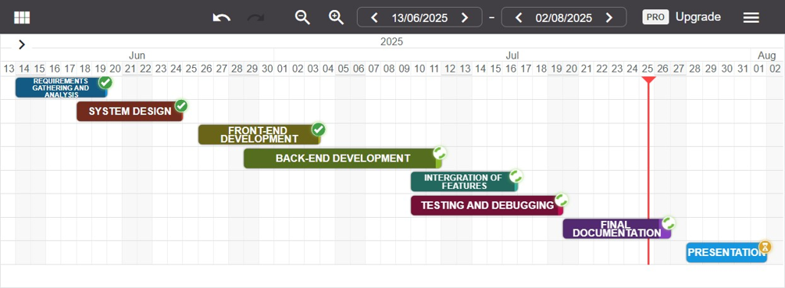
WBS | Task description | Start date | Duration (days) | Finish date | Progress
1 | REQUIREMENTS GATHERING AND ANALYSIS | 14/06/2025 | 5 | 19/06/2025 | 100%
2 | SYSTEM DESIGN | 18/06/2025 | 6 | 24/06/2025 | 100%
3 | FRONT-END DEVELOPMENT | 26/06/2025 | 8 | 03/07/2025 | 100%
4 | BACK-END DEVELOPMENT | 29/06/2025 | 10 | 09/07/2025 | 98%
5 | INTERGRATION OF FEATURES | 10/07/2025 | 6 | 16/07/2025 | 98%
6 | TESTING AND DEBUGGING | 10/07/2025 | 9 | 19/07/2025 | 95%
7 | FINAL DOCUMENTATION | 20/07/2025 | 7 | 26/07/2025 | 80%
8 | PRESENTATION | 28/07/2025 | 5 | 01/08/2025 | 0%

Appendix B – Contribution by Team Members
No. | Team Member | Contribution
1. | ATUGONZA MATHIAS | - Designed and integrated the database schema.  - Implemented user authentication and authorization modules.  - Implemented emergency logical system and alert features.
2. | IGA AALIYAH | - System analysis and problem definition.  - Developed the front-end components (web version).
3. | LUBANGA SHAFICK | - Implemented user authentication and authorization modules.  - Managed GitHub repository and version control.  - Deployed prototype to cloud (test environment).
4. | SSERUWAGI MARVIN | - Prepared project documentation.  - Conducted system testing and debugging.  - System analysis and problem definition
5. | AHURIRA GRACE | - Worked on notification services (Push, in-app).  - Prepared project documentation.  - Developed the front-end components (web version).

